Dl Hennabloom Store
Mangement System
By Dhanalakshmi.K(E25AI110)

- Entities and Attributes
Customer
Primary Key: Customer_ID
Attributes:
- Name
- Customer_ID
- Email
- Phone
- Address

Category
Primary Key: Category_ID
Attributes:
- Category_ID
- Category_Name

Product
Primary Key: Product_ID
Foreign Key: Category_ID
Attributes:
- Product_ID
- Product_Name
- Category_ID
- Price
- Stock
Cart
Primary Key: Cart _ID
Foreign Key : Customer_ID
Attributes:
- Cart_ID
- Customer_ID
- Created_Date

Cart Item
Primary Key: CartItem_ID
Foreign Keys: Cart_ID , Product_ID
Attributes:
- CartItem_ID
- Cart_ID
- Product_ID
- Quantity

Order
Primary Key: Order_ID
Foreign Key: Customer_ID
Attributes:
- Order_ID
- Customer_ID
- Order_Date
- Total_Amount
Order Item
Primary Key: OrderItem_ID
Foreign Keys: Order_ID , Product_ID
Attributes:
- OrderItem_ID
- Order_ID
- Product_ID
- Quantity
- Price

Payment
Primary Key: Payment_ID
Foreign Key: Order_ID
Attributes:
- Payment_ID
- Order_ID
- Payment_Method
- Payment_Status

Reviews
Primary Key: Review_ID
Foreign Keys: Customer_ID , Product_ID
Attributes:
- Review_ID
- Customer_ID
- Product_ID
- Ratings
- Review

Wishlist
Primary Key: Wishlist_ID
Foreign Keys: Customer_ID , Product_ID
Attributes:
- Wishlist_ID
- Customer_ID
- Product_ID

- Entities Relationship diagram:
The following figure represents the Entity Relationship Model of the DL Hennabloom Store Management System, designed using Power BI Model View. It illustrates the relationships between the entities based on their Primary Keys (PK) and Foreign Keys (FK), ensuring data integrity and efficient database management.
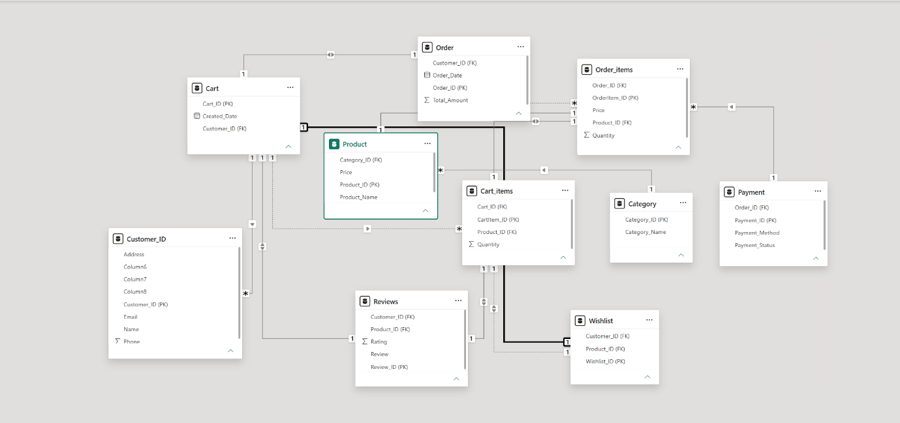

- Relationships Between Entities:
Relationship | Cardinality | Description
Cart_items → Cart | Many-to-One (M:1) | A single cart can contain multiple cart items, but each cart item belongs to only one cart.
Customer → Cart | One-to-Many (1:M) | A customer can have one or more carts, and each cart belongs to one customer.
Order → Cart (Customer_ID) | One-to-One (1:1) | Each customer's cart is associated with one order, and each order belongs to one customer.
Order_items → Order | Many-to-One (M:1) | An order can contain multiple order items, but each order item belongs to one order.
Order_items → Payment | Many-to-One (M:1) | Multiple order items are linked to a single payment made for the order.
Order_items → Product (Price) | One-to-One (1:1) | Each order item records the price of a product at the time of purchase.
Order_items → Cart_items (Product_ID) | One-to-One (1:1) | Each ordered product corresponds to a product previously added to the cart.
Product → Category | Many-to-One (M:1) | A category can contain many products, but each product belongs to only one category.
Reviews → Cart (Customer_ID) | One-to-One (1:1) | A customer is associated with a review, and each review belongs to one customer.
Reviews → Cart_items (Product_ID) | One-to-One (1:1) | Each review is written for one product, and each product review refers to one product.
Wishlist → Cart (Customer_ID) | One-to-One (1:1) | Each wishlist belongs to one customer, and each customer has one wishlist.
Wishlist → Cart_items (Product_ID) | One-to-One (1:1) | Each wishlist entry refers to one product, and each product entry is uniquely stored in the wishlist.

